Source: "Source Water Protection for Concentrated Animal Feeding Operations: A Guide for Drinking Water Utilities"; Gullick et al., ©AwwaRF 2006

SWINE OPERATIONS (WILMINGTON, NORTH CAROLINA)

City of Wilmington Water Supply

The City of Wilmington, North Carolina obtains their source water from the Cape Fear River, and treats an average of 17 mgd with pre-ozonation, coagulation, clarification, ozonation, dual-media filtration (with granular activated carbon), and chlorine disinfection. The ozonation process was added to reduce DBP precursors and other natural organic matter to help comply with the Disinfectant and Disinfection Byproduct and Surface Water Treatment Rules.
While there are swine, beef cattle, dairy cattle, chicken, and turkey CAFOs in their watershed, the swine CAFOs are the most significant in terms of number, size, impact, and economic importance. The water utility does not coordinate efforts directly with the CAFOs (there are close to 1,000-swine CAFOs within the Cape Fear River basin), and instead relies on the North Carolina Department of Environment and Natural Resources (NCDENR) to monitor the waste management practices of the CAFOs. The utility does monitor source water quality at their intake to assess changes in conditions. This monitoring includes both on-line as well as grab samples for a variety of parameters. They consider their measure of success to be effective, efficient and economical treatment of the source water. Their future goals for source water protection related to CAFO wastes include increased monitoring and source water protection efforts; increased dialogue, communication and partnership with all parties involved; and proactive approaches for remediation of potential problems.

Growth of Swine Operations in North Carolina

Agriculture and its related businesses are North Carolina’s number one industry. Among the most significant agricultural producers are the swine and poultry industries. These industries have changed significantly in recent years, generally moving from small farms toward large integrated confinement operations. There was a substantial increase in the number of hog CAFOs in eastern North Carolina in the 1990s. For example, from 1984 to 1994 the number of swine farms in the state dropped from 21,000 to 7,000, while the total number of swine increased. Between 1993 and 1996 alone the total number of swine in the state increased from approximately 4.5 million to 8.5 million (Agricultural Animal Waste Task Force 1996).
This explosion in the growth of swine farms and their accompanying on-site waste lagoons resulted in a temporary moratorium (through 1999) on the construction of new swine waste lagoons being issued by the State in August 1997 (General Assembly of North Carolina 1997; NC House Bill 515), which has been extended several times and now goes through September 1, 2007 (per General Assembly of North Carolina, 2003, Senate Bill 593). The purpose of the moratorium was to allow time for counties to adopt zoning ordinances, for scientific studies previously authorized by the state to be completed, and for the state to act on the findings and recommendations of those studies.
That same law also directed the state Department of Agriculture to develop (by May 1, 1998) a plan to phase out the use of anaerobic lagoons and sprayfields as primary methods of disposing of animal waste at swine farms. Nonetheless, lagoon systems and spray fields are presently the dominant treatment method for swine wastes in the state, presumably at least in part due to the substantial political clout and resistance from the state’s pork industry to move toward more expensive and advanced waste treatment methods.
Motivation for the moratorium came from considerations of the potential of lagoons to leak and pollute groundwater or surface water, the potential for pollution from spraying of the liquid wastes on pasture and crop fields, and the risk of lagoon berm failures as exemplified by the recent breaking of several lagoon walls during periods of heavy rains, which resulted in large volumes of liquid wastes being discharged directly into nearby surface waters. The largest of these accidents was a major break of the retaining wall of an 8-acre lagoon at Oceanview Farms in Onslow County in June 1995, which spilled approximately 22-million gallons of liquid manure waste into the New River (Agricultural Animal Waste Task Force 1996).

State Regulation and Inspection of Swine CAFOs

A site visit was conducted to the office of the Wilmington Region of the NCDENR (Water Quality Division), which covers seven counties with a total of approximately 680-hog CAFOs (approximately 500 of them are in Duplin County alone). The Wilmington Region does not cover the whole watershed of the Cape Fear River, and there are substantial numbers of hog CAFOs in other nearby counties that are within the watershed but under the jurisdiction of different Regions of the NCDENR (e.g., Sampson County, which is adjacent to Duplin County).
The state of North Carolina regulates waste from animal operations under 15 North Carolina Administrative Code 2H .0217, Waste Not Discharged to Surface Waters (referred to as the ".0200 rules"). The NCDENR is responsible for the permitting process for CAFOs in the state. Any hog farm with at least 250 hogs is required to have at least a State General permit, and any hog farm with 2,500 or more hogs that weigh 55 pounds or greater is required to have a NPDES permit. In the next year or two, there is a possibility that the majority of the North Carolina hog farms that currently are subject to an NPDES permit will be allowed to revert to a State General permit due to the February 25, 2005 ruling by the U.S. 2nd Circuit Court of Appeals (Waterkeeper Alliance Inc. et al. v. USEPA, 399 F.3d 486, 2nd Cir. 2005). For updates on the status of AFO regulations in North Carolina, see http://h2o.enr.state.nc.us/aps/ afou/news.htm.
These hog farms are inspected twice per year, once by the Water Quality Division of NCDENR and once by the Soil and Water Division of NCDENR. The latter group tends to provide more technical guidance to the CAFOs, while the former focuses more on determining CAFO compliance with the applicable permits and regulations. The NCDENR Division of Water Quality also conducts visual fly-over inspections after storm events to identify lagoons that have high water levels or may have overflowed, for runoff from the properties, and for active spraying of lagoon effluent after rain or in areas with standing water. The first NPDES permit for a hog farm in North Carolina was issued in March 2001.
Different factors restrict NCDENR’s ability to more rigorously monitor CAFOs in the state. As is the case with many state agencies, staffing available for inspections and permit oversight is limited (e.g., the Wilmington Region of the NCDENR Division of Water Quality has three inspectors for approximately 680 swine CAFOs). Political pressure apparently affects the NCDENR’s ability to study the influence of CAFOs on groundwater and surface water resources in the state, including the ability to conduct sampling and monitoring programs. The state conducts limited surface water monitoring (and mostly only on larger tributaries), and no groundwater monitoring designed to assess potential impacts from CAFOs.
The NCDENR’s on-site hog CAFO inspections focus on potential discharges, the waste collection and treatment systems (e.g., rainfall records and lagoon liquid levels), land application of wastes (e.g., records for sprayer calibrations and spray volumes, analytical results of annual soil sampling), required records and documentation, and other issues such as disposal of dead animals and odor and air quality concerns. Some of the top regulatory requirements that are considered to be directly beneficial to the environment are the required soil and liquid waste analyses (so the CAFO operator knows what they are dealing with), and the mandating of adequate freeboard levels for the lagoons. The soil tests primarily look for metals, pH, phosphorus and potassium. Application of liquid lagoon waste on the fields is sometimes restricted due to soil metals content (especially zinc and copper); once the soil metal standards are reached the facility can’t apply any more animal waste on that field. Nitrogen is very mobile so it is not tested here.
The NCDENR inspections also have clearly helped. For example, when these inspections were first started several pipes were found leading from waste lagoons to nearby creeks, but it is now rare for such pipes to be found during inspections. Most of the problems identified during more recent inspections have dealt with record keeping, issues related to land application of liquid waste, and occasionally the identification of lagoons that are filled higher than they are supposed to be (i.e., less freeboard than required).

Example Swine CAFOs

Seven-hog CAFOs were visited in eastern North Carolina (Figure 7.8) in conjunction with scheduled inspections by NCDENR Division of Water Quality personnel. These farms are located in two different subwatersheds, the northeast Cape Fear River and the Black River, both of which drain into the Cape Fear River, which the City of Wilmington uses as their source water. All seven of the farms have the same owner, and are operated by a contract staffing company that provides manpower, utilities, management, and waste management services. The integrator owns the hogs, and provides the food, drugs, and transportation of the hogs. These operations, including related crop land, comprise over 600 acres.
Built in the mid-1990s, these seven farms have a total of approximately 52,000 hogs. One of the farms is a nursery operation, and the rest are all finishers (where the hogs are grown to market weight). There are four to six buildings per site. Some of the finisher buildings are completely roofed (‘1224’ buildings, named because their capacity is 1,224 hogs), and others are in the ‘Missouri style’ where only half of each pen has a roof (these have a capacity of approximately 1,320 hogs).
The hogs reside in pens with an area of concrete slats where their feces and urine fall through to a receiving pit channel. Waste in the pits is regularly flushed (approximately five times per day) to an on-site lagoon. The flush water used is recycled lagoon supernatant - lagoon water is pumped back to the flush tanks (adjacent to the hog barns) which store that water for use in flushing the pits.

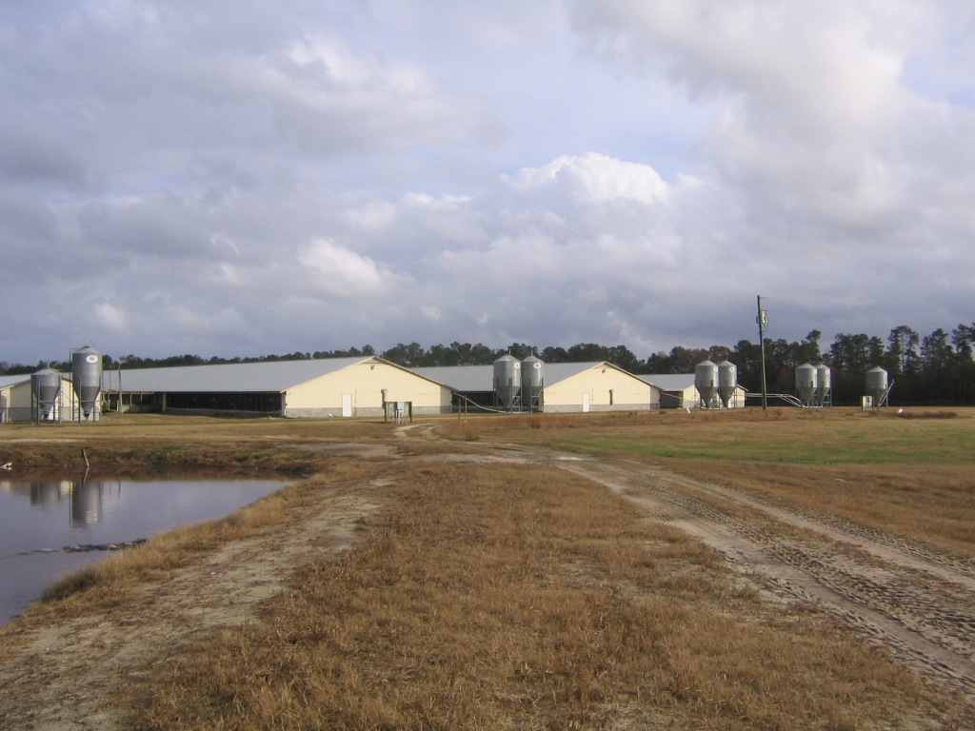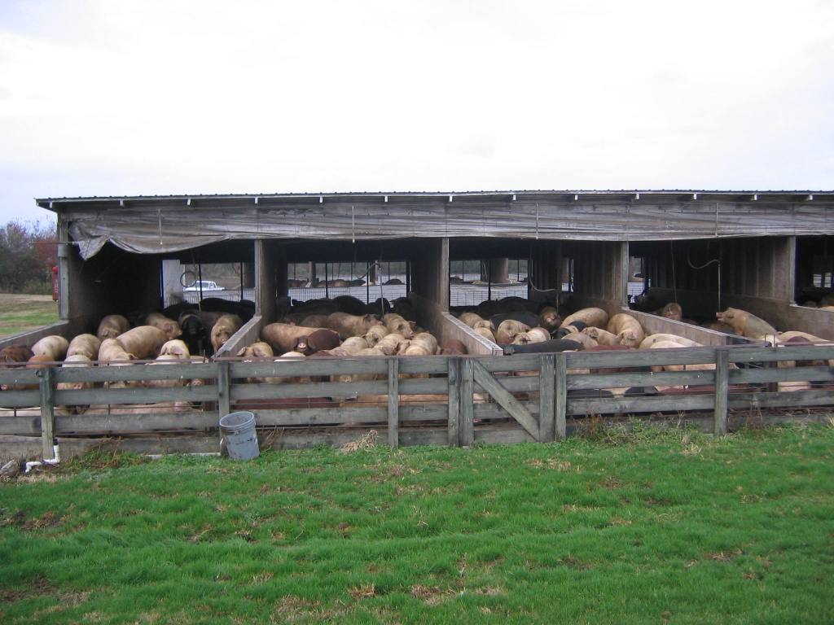
Up to 1,224 hogs are housed in each of the 5 This ‘Missouri-style’ shelter can house up to
enclosed shelters at this N. Carolina CAFO 1,320 hogs

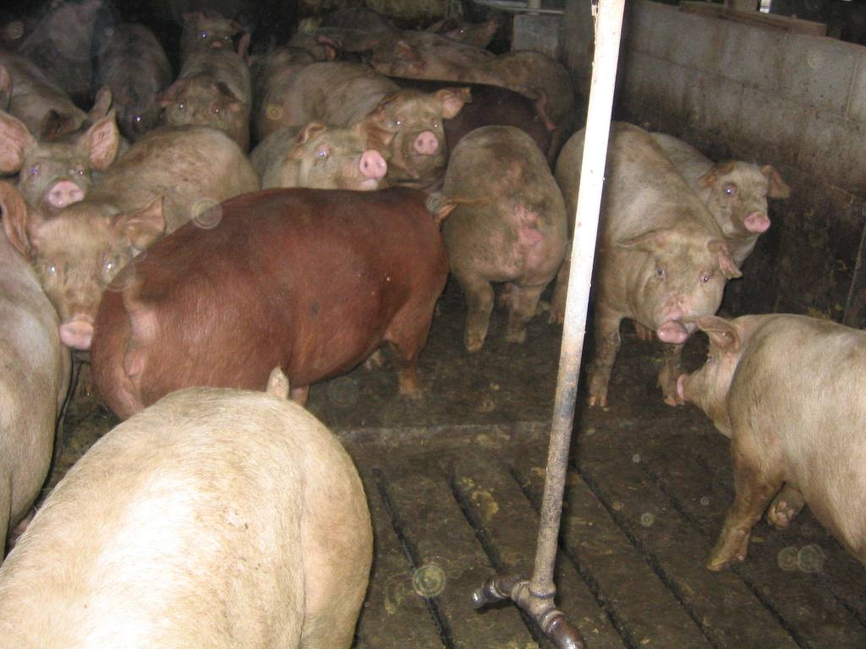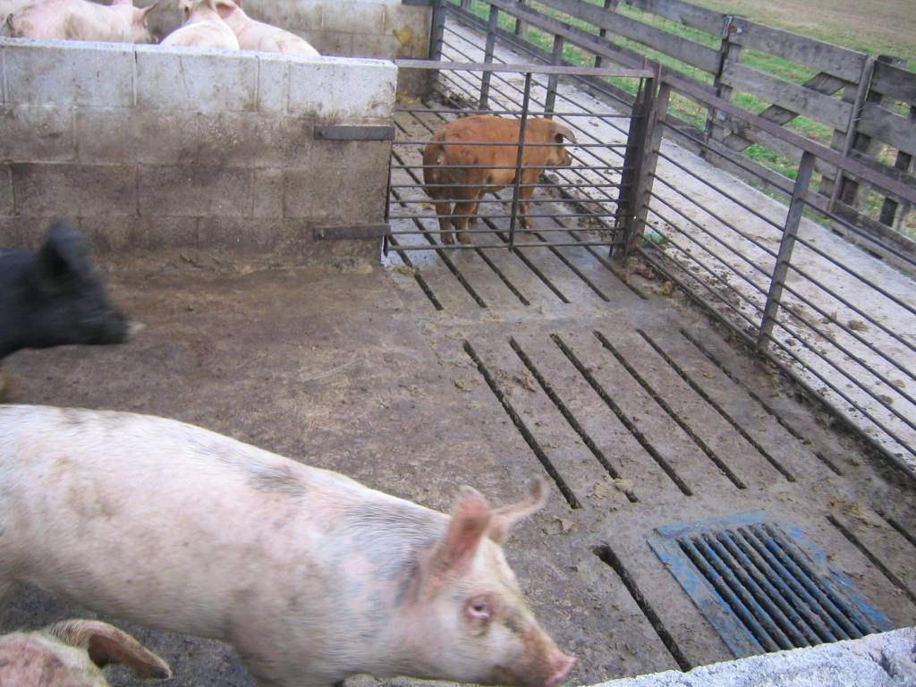
Drinking water spillage (and thus part of the Manure falls through slats in the pen floors
volume of wastewater generated) is reduced to a receiving pit channel. The pits are flushed
by the use of nipple waterers five times a day using recycled lagoon water

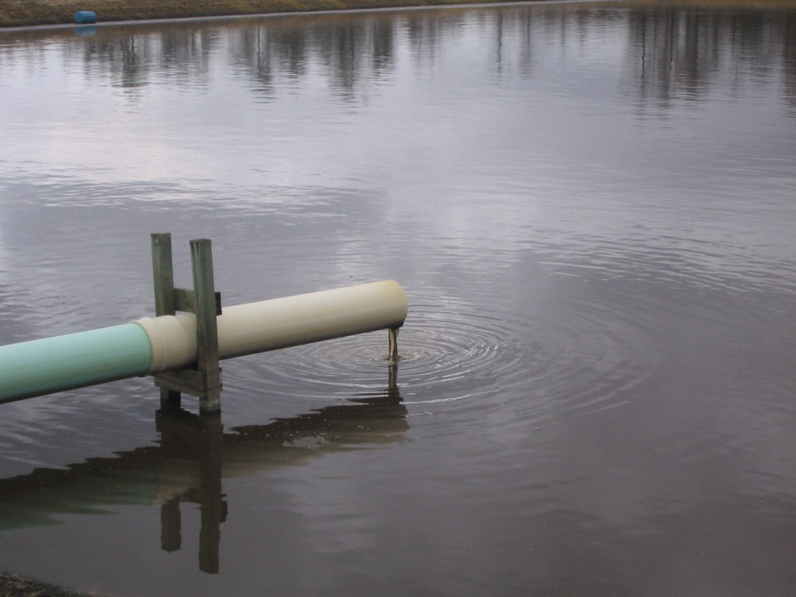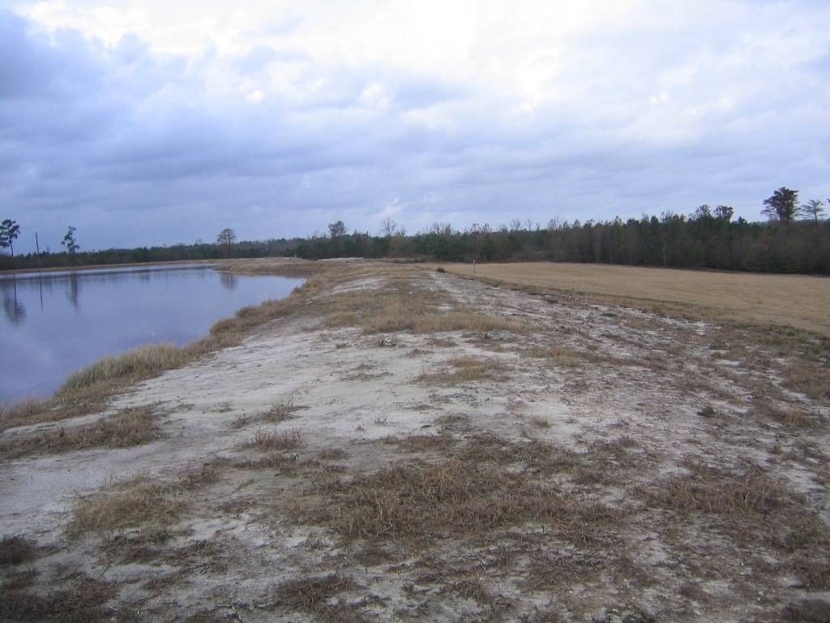
Hog manure discharges to an anaerobic Poor vegetative cover on a lagoon berm can
lagoon with an 18-inch compacted clay liner lead to erosion and affect berm integrity.

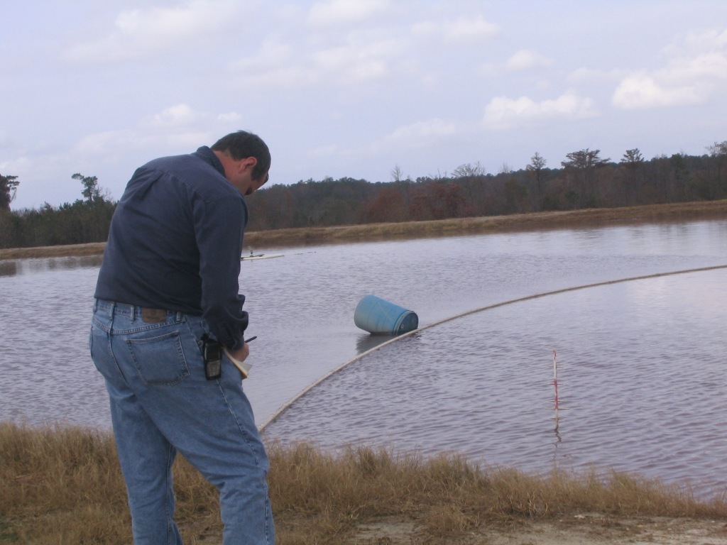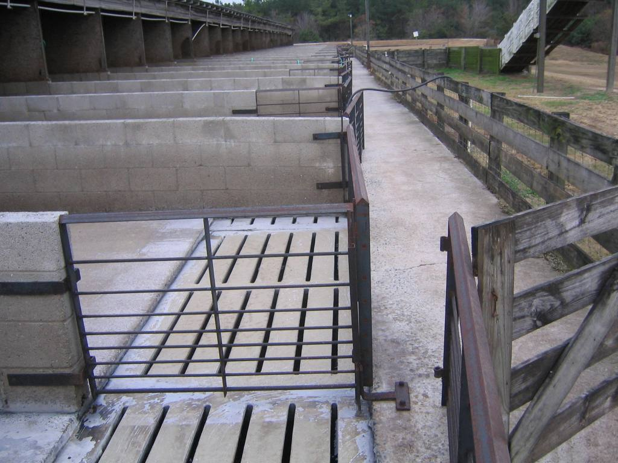
State inspections of hog farms is an important Antiseptic solution is used to clean out the
tool. This NCDENR inspector is vigilant pens between shifts of hogs. This washwater
checking berms and lagoon freeboard levels also goes into the lagoon

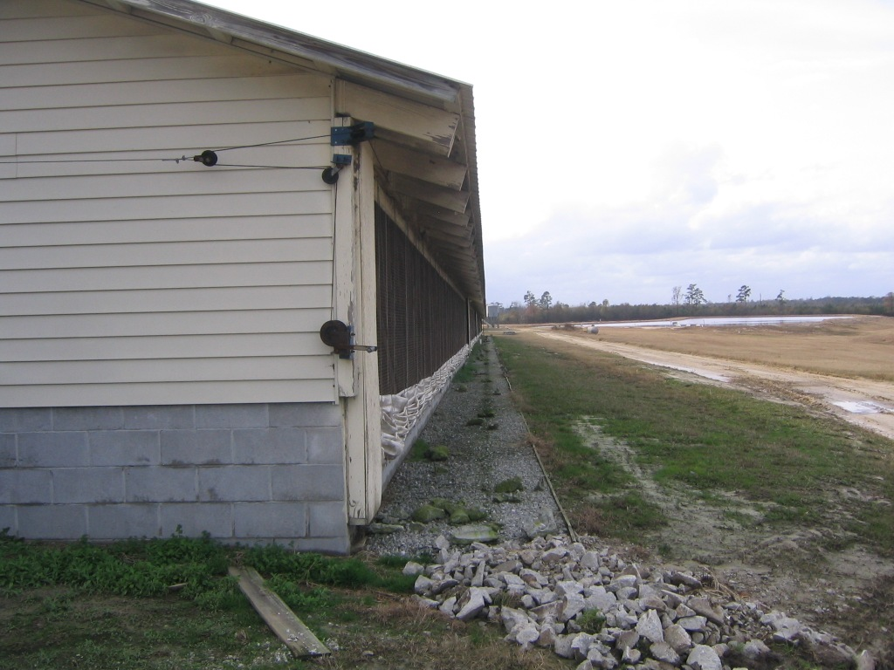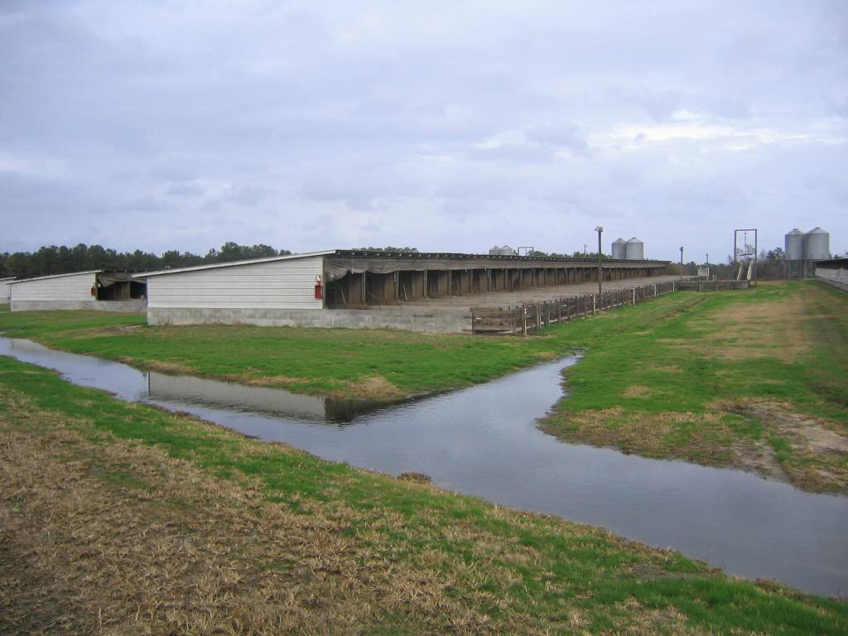
Stormwater management for roof runoff Stormwater ditches move rainwater away
includes gravel and stone drainage systems from the animal holding areas and lagoon

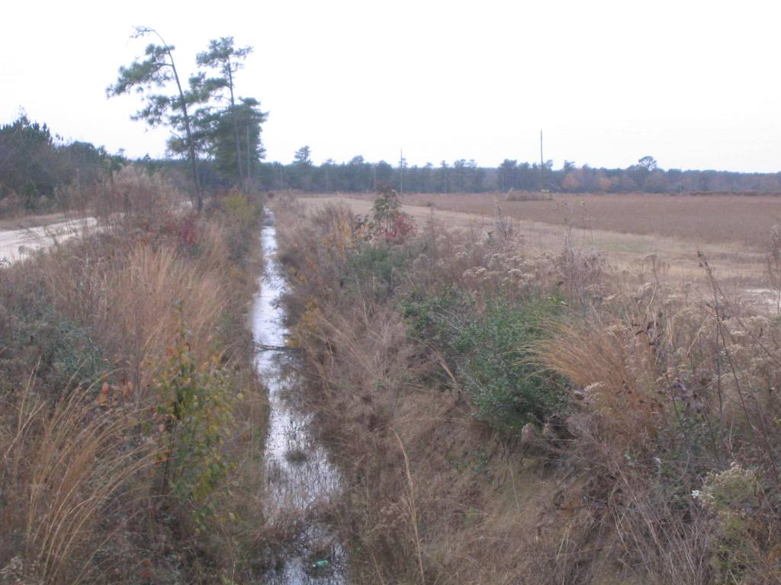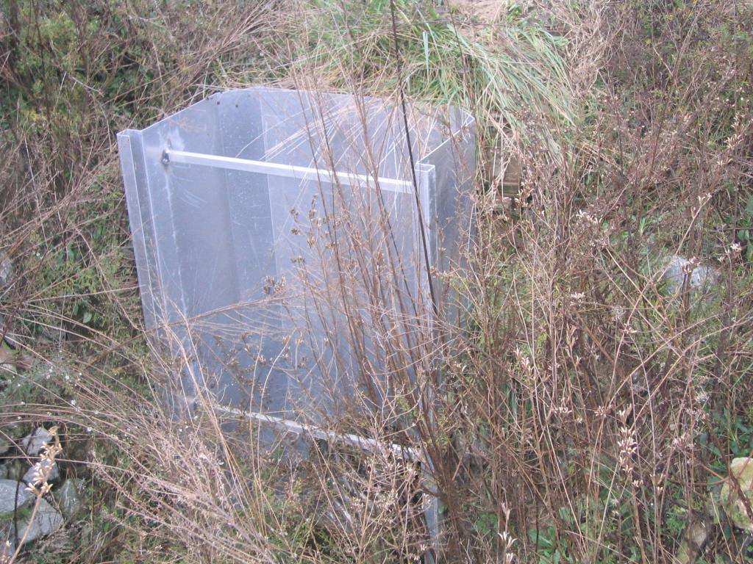
Natural riparian buffers are left adjacent to This drainage ditch has a sluice gate that can
drainage channels to reduce sediment and be shut in the event of a major lagoon break
nutrient flow off-site to stop flow into nearby waterways

Figure 7.8 Photographs of swine CAFO operations
The lagoons are constructed on 18 inches of compacted clay soil, and provide both settling and anaerobic treatment, as well as storage capacity. The lagoons are built to include some permanent waste and sludge storage, plus six months of waste storage capacity. In addition to that, the level of the liquid in these lagoons (compared to the lowest point of the retaining berm) is regulated to be below a level that includes 12 inches of freeboard (required for structural stability), an additional unused 7.5 inches of storage for a 25-year, 24-hour storm event, and, for lagoons constructed after 1996, another 7.5 inches as a safety factor against heavy rainfall, for a total of 27 inches of freeboard at all times (the depth required for the 25-year/24-hour storm event will vary depending on the location of the farm, and ranges from 5 to 9 inches depending on the location in North Carolina; the heavy rainfall safety factor must be no less than the amount for a 25-year/24-hour storm event). The NCDENR inspector was rigorous in determining the freeboard level at the lagoons at all seven farms visited.
Most of the waste handling is liquid, and that is a 365 day-per-year operation. The sludge solids in the lagoons are removed only once every 10 to 15 years. Sometimes it can be problematic for the operator to find a neighboring farm that has use for lagoon sludge solids as free fertilizer since it is quite high in nitrogen, phosphorus, and metals levels.
Lagoon supernatant is disposed of via land spraying as fertilizer on nearby fields of corn, wheat, soybeans, and Bermuda grass under conditions mandated by a required Nutrient Management Plan. At present these NMPs are based on soil nitrogen requirements, but are in the process of being modified to be based on phosphorus requirements using a Phosphorus Loss Assessment Tool (PLAT). All larger hog farms subject to NPDES permits in the state are required to use the PLATs in updating their NMPs.
Stormwater management for roof runoff includes gravel and stone drainage systems. Stormwater ditches direct rainwater away from the animal holding areas and lagoon. Natural riparian buffers are left in place next to farm drainage channels. Some drainage ditches have sluice gates that can be shut in the event of a major lagoon break to stop the wastewater from entering nearby waterways.
Dead hogs are ‘rendered’, i.e., taken away for disposal by a third party who grinds them up for use in animal feed, as a base product for cosmetic products, and other uses. Dead hogs are placed in a nearby dumpster, or ‘dead box’ (also known as an ADU container, or animal disposal unit container), which is checked once each day by the third party that removes them from the farms. Elsewhere in North Carolina dead hogs may also be buried or incinerated, and some farms have used composting.
The operator claims to be a proponent of reasonable and consistent regulations. However, they noted there have been lots of regulatory changes over the years, and that shortly after they become accustomed to a set of regulations, the regulations tend to get changed and their staff needs to do more work.

Effects of Hurricane Floyd

Most CAFOs are classified and permitted as nondischarge facilities under the assumption that all waste is contained onsite (including spraying of liquid wastes on nearby fields). However, heavy rain events can create substantial problems with the concept of no discharge. As noted by the operators of the beef cattle CAFOs visited in Texas, the regulations imposed do not account well for the variability in weather often encountered. In the case of swine lagoons, large storms can potentially fill the lagoons, thus requiring disposal of the liquid waste during conditions that are not optimal (i.e., irrigation onto saturated soil).
Severe storm events can potentially create serious pollution problems. For example, Hurricane Floyd brought a massive rain storm to eastern North Carolina on September 9, 1999, with over 20 inches of rain falling within 24 hours in some areas. This storm was greater than a 100-year flood, and wreaked havoc on much of the area. Impacts on some hog CAFOs were severe. The impact of subsequent flooding on confinement buildings, waste pits, and spray fields, as well as large numbers of drowned animals, was well documented. For example, the NCDENR confirmed 46-hog operations with breached or flooded fecal waste pits as a result of Hurricane Floyd’s rain (Wing et al. 2002). During Hurricane Floyd, lagoons used by the operator of the sites visited (as part of this project) did not overflow from the rainfall, but instead some creek waters flowed over the lagoons.
Estimates of the number of animals killed in the flooding are as high as 100,000 hogs, 2.4 million chickens and 500,000 turkeys (www.nandotimes.com/nt/images/floyd/floyd063.html). For a sampling of graphic photos of Hurricane Floyd’s impact on hogs farms, see the following (from www.nandotimes.com/nt/images/floyd/index.html).

- www.nandotimes.com/nt/images/floyd/floyd022.html
- www.nandotimes.com/nt/images/floyd/floyd050.html
- www.nandotimes.com/nt/images/floyd/floyd051.html
- www.nandotimes.com/nt/images/floyd/floyd081.html
- www.nandotimes.com/nt/images/floyd/floyd085.html

After assessment of the damage caused by the flooding of Hurricane Floyd, the State of North Carolina implemented a “buy-out” program supported by federal funding to purchase hog facilities and waste lagoons (but not all the adjacent farm land) that were in the 100-year flood plain and were flooded during Hurricane Floyd.

